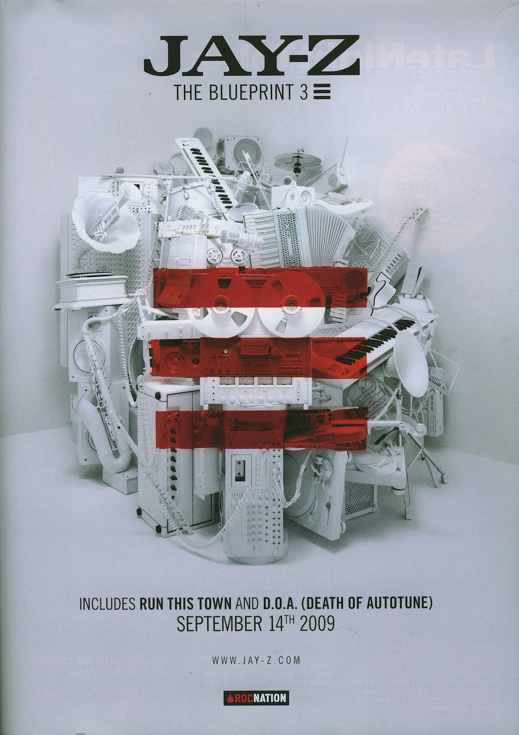

The main purpose of this advert is to increase awareness of Jay Z album. This picture illustrates that music is a form of art and with his name in a bigger font allows the audience to think that Jay Z is the best in the music industry. The three red stripes across the picture suggests Jay Z’s passion and love for music as red symbolizes this.

The artist name is at the top of the page so that the reader’s eyes are attracted to this. We will be adopting this technique because the artist name is like a brand and needs to be remembered.

As the reader’s eyes move down the poster, factual information is printed at the bottom of the poster, this informs the reader of the singles that appear on the album alongside the date of release. Without this information there would not be a sense of urgency to buy the album on the release date.

The website is smaller font acts as a marketing tool for the artist allowing fans to visit the website for greater information and to explore the merchandise.

I believe that the most effective elements of this poster are the title of the album which is stating that his album is the original and other artists are inspired by his music.