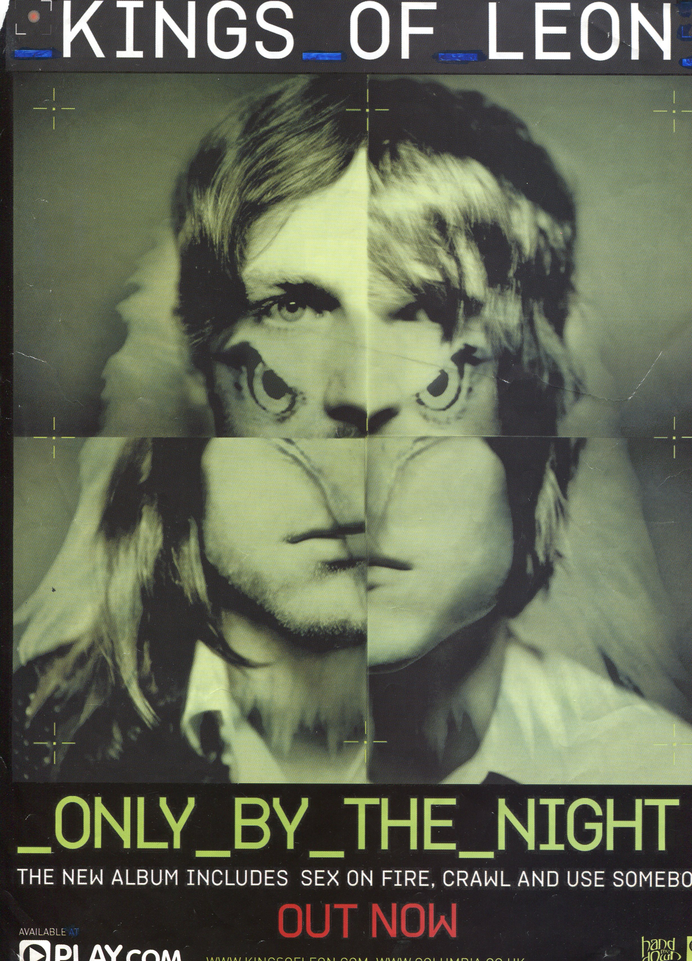

This poster is similar to the Jay Z poster as the name of the artist is printed at the top of the poster ensuring the audience focus on the artists name so they can remember the artist like remembering brands. The font is also important as the underscores are suggesting that the bands are up and coming and express their music differently to other artists.

The image itself takes up the majority of the page showing a college of a man and an eagle combined suggesting that the band have different sides to them such as power and strength. Furthermore, that their style is a mixture of two genres and are something the world haven’t experienced before.

The colour green suggests that they are the future of the music industry by using colour schemes in science fiction films, which have been majorly successful across the world. The colour is not only used, as a tint for the image but is the colour of the title of the album.

Finally, the red coloured ‘Out Now’ statement stands out from the rest of the poster from the use of this colour. The statement itself suggests to the audience that the audience has to buy the album before stocks vanish.

At the bottom of the poster is an advertisement of the stores that sell the album such as Play.com suggesting only one store holds the album making audiences visit this website.